Overview
The Faculty of Education Online Peer Review criteria reflect the elements of effective learning environments identified in Garrison, Anderson & Archer’s (2000) ‘Community of Inquiry’ (CoI) model (Figure 1). The now well-validated CoI model “represents a process of creating a deep and meaningful (collaborative-constructivist) learning experience through the development of three interdependent elements – social, cognitive and teaching presence”. The review criteria are also informed by the literature on effective assessment practices and the role of feedback in teaching and learning (see for example Anderson & Krathwohl, 2001; Chickering & Ehrmann, 1996).
As the CoI model developers explain:
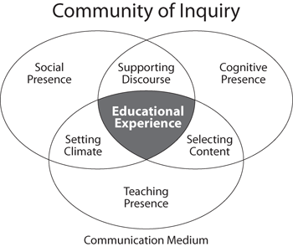
Social presence is “the ability of participants to identify with the community (e.g., course of study), communicate purposefully in a trusting environment, and develop inter-personal relationships by way of projecting their individual personalities.” (Garrison, 2009)
Teaching Presence is the design, facilitation, and direction of cognitive and social processes for the purpose of realizing personally meaningful and educationally worthwhile learning outcomes (Anderson, Rourke, Garrison, & Archer, 2001).
Cognitive Presence is the extent to which learners are able to construct and confirm meaning through sustained reflection and discourse (Garrison, Anderson, & Archer, 2001).
Figure 1. The community of inquiry model (from Garrison et al., 2000)
Social, teaching and cognitive presences may be supported by both elements of course design and by instructional practice.
This Peer Review Worksheet has two sections. Part A focuses on course content and design; Part B focusses on course instruction. For some reviews, only Part B will be relevant. The Course and Instructor Overview sheet completed by the instructor, as well as conversation with the instructor, will guide which sections are completed.
The criteria indicated in each section below are intended as a guide for reviewers. The list is not exhaustive, and not all courses will call for evaluation of all items.

https://coi.athabascau.ca/coi-model/

